Reactions Of Alkenes

Alkenes have a pi bond, a region of electron density above the C-C bond. The C=C bond is comprised of one strong sigma bond, and one weaker pi bond, so overall the strength of a C=C bond is not quite double a normal C-C bond.

It is possible to break the pi bond but not the sigma bonds, so alkenes can undergo addition reactions.
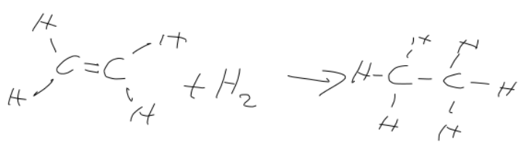
There are 3 types of reaction that can occur:
- Hydrogenation:
  - Add hydrogen
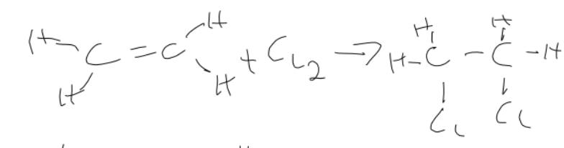
  - nickel catalyst
  - 423K temperature
- Halogenation:
  - Add halogen / halogen halide
  - no catalyst
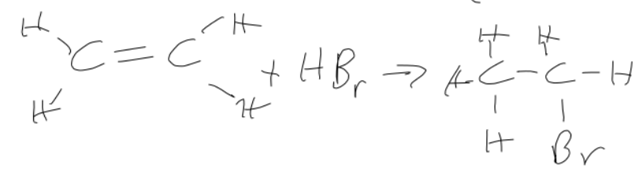
  - room temperature
- Hydration:
  - Add steam
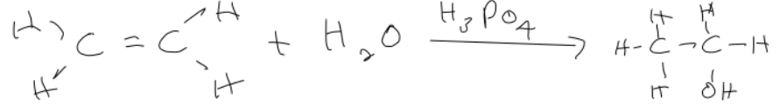
  - H₃PO₄ catalyst.

Electrophilic addition

A pair of electrons moves from the double bond of the alkene to the hydrogen.
The electrons shared with the hydrogen go completely to the Br as the hydrogen leaves.
The now negative Br is attracted to the positive carbon (carbocation), forming a bromoethane.

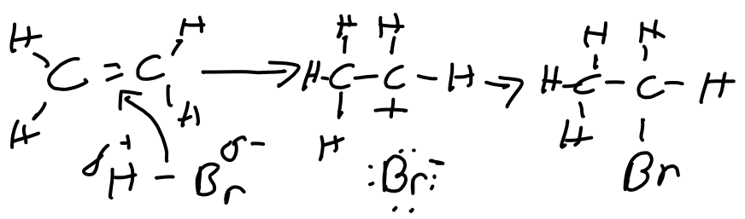
This also works with halogens, e.g. Br-Br:

